Assignment 3 – Design Concepts

(/70 points)

| **Due date:** | See CANVAS for submission deadline and instructions |
| --- | --- |
| **Objective:** | The goal of this assignment is to generate preliminary design concepts that satisfy user needs, as well as design objectives and constraints. |

1. Design Concept Brainstorm (/20 points)
2. Brainstorm a wide range of design concepts to address your design need. These may include full-system designs and/or various subsystem designs. Use the methods discussed in the course reader (Chapter 7) to come up with at least 20 different concepts. Document your design concept brainstorm by providing readablesketches with figure titles (e.g. “Figure 1: Concept for a ….”). Design concepts from your brainstorm can be photos or scans of hand drawings (/17 points).

| **Functions** | **Concept 1** | **Concept 2** | **Concept 3** | **Concept 4** | **Concept 5** | **Concept 6** |
| --- | --- | --- | --- | --- | --- | --- |
| **Weather Protection for Electronics** | Gel on electronic components | Rubber Rings | Hard removable cover | Umbrella | Wheel wells for motors | Wide feet for muddy conditions |
| **Power System and Batteries** | Large Central (Swappable) Battery | Dual Batteries at Edges | Wireless Charging System | Quad Batteries | Array of off the shelf batteries | Solar panels |
| **Carrying Case** | Charging Case | Case with dual purpose lid | Clamp Lid Case | Folding Fabric Case |  |  |
| **Modular Connection System** | Bolt Mounted | Latching System | Custom Power and Data Connector | USB Data Connector + 12V SAE connector |  |  |
| **Part Printing Method** | Redesign printed parts, rework orientation |  |  |  |  |  |
| **Handle** | single top handle | two side handles | inset handle |  |  |  |

**Weather Protection for Electronics**

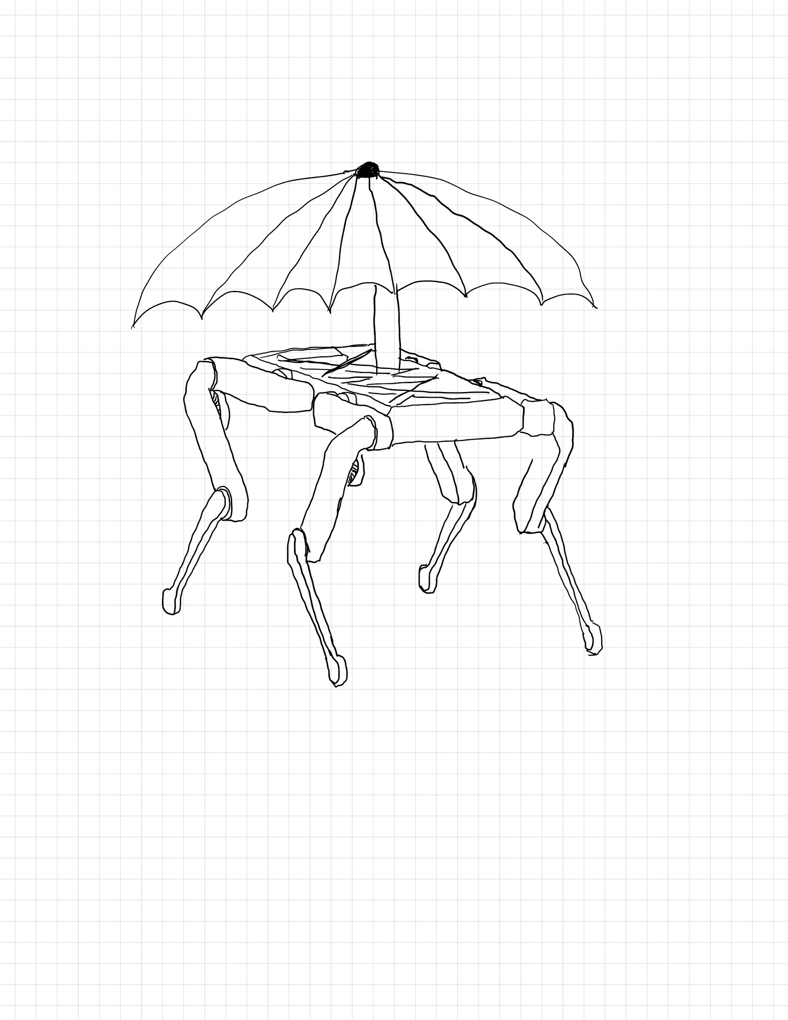

Figure 1. An umbrella is mounted to the chassis of the robot to act as a weather proof shield against rain and UV radiation (which could wear the PLA).

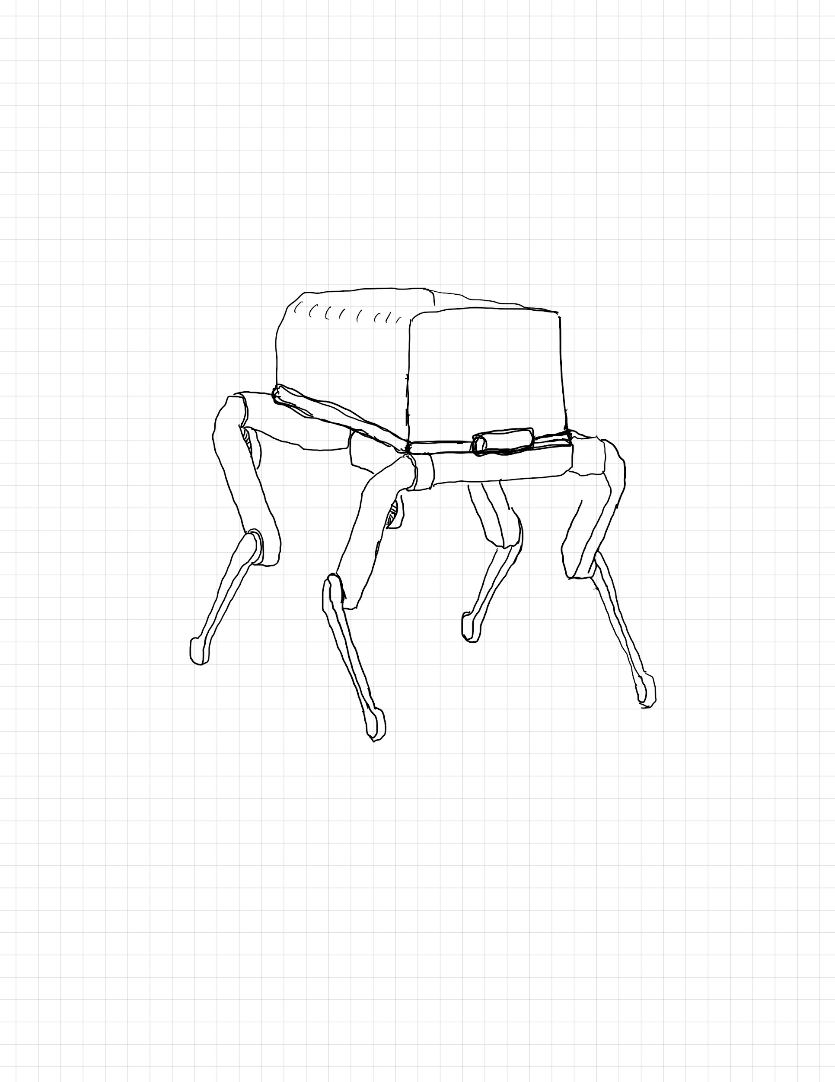

Figure 2. A simple plastic storage bin with a latching lid is installed upside down on the robot to act as a waterproof shell. Only the rim of the lid would be used to allow access to the electronics.

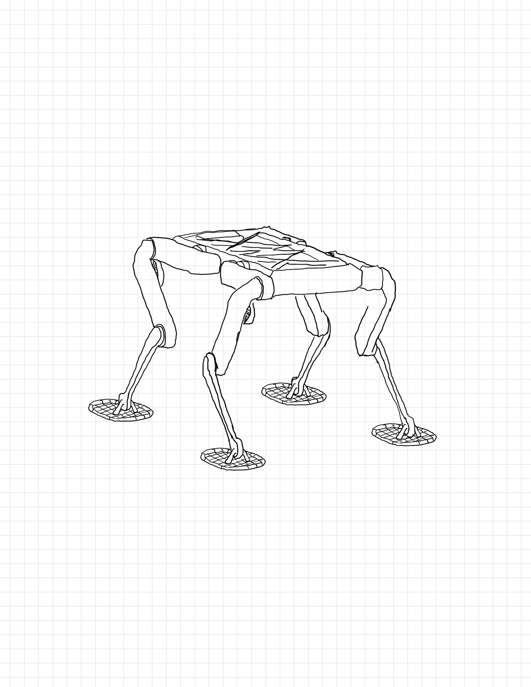

Figure 3. Larger footprint feet are attached to the existing feet to allow the robot to traverse mud or snow which may be present in the research field.

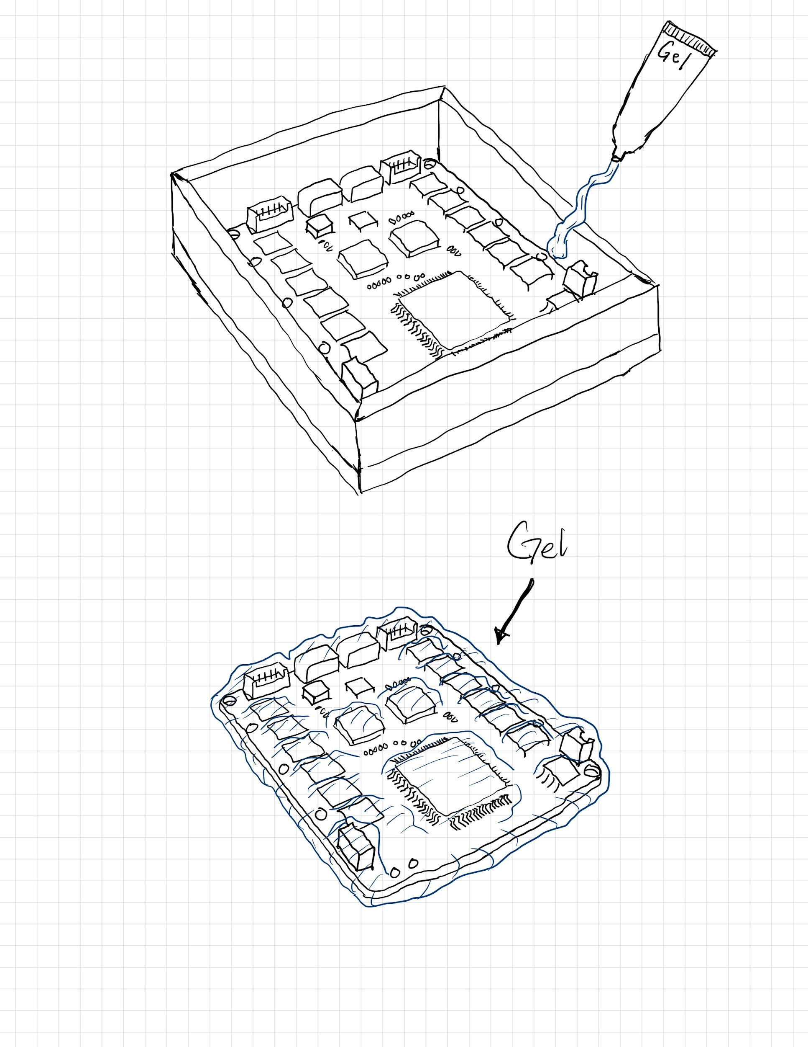

Figure 4. Gel is used to weatherproof the electronics in lieu of a cover.

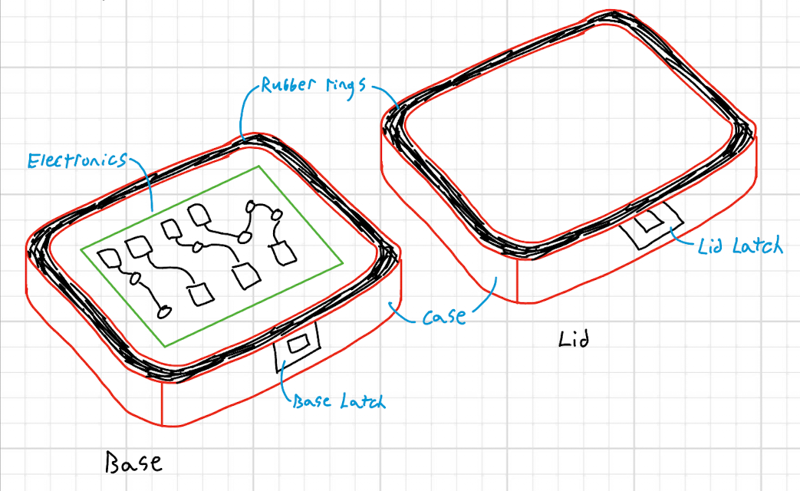

Figure 5. The rubber ring (in black) sits around a case that encloses the electronics. This helps waterproof the electronics from weather or sprinklers.

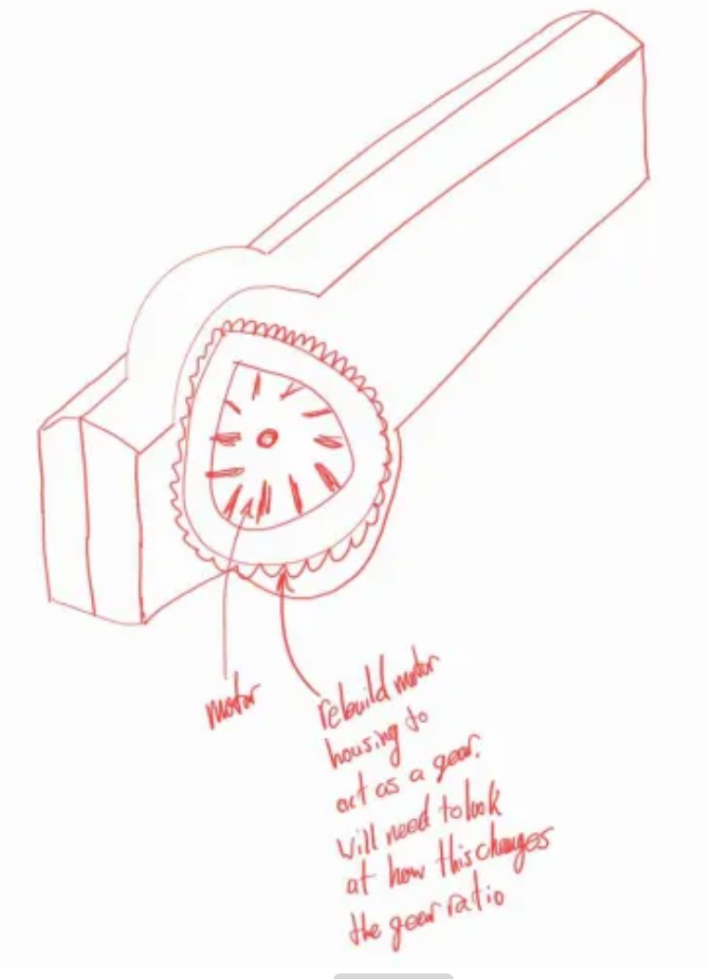

Figure 6. Integrating the motors into the legs and adding “wells” around them to increase water protection.

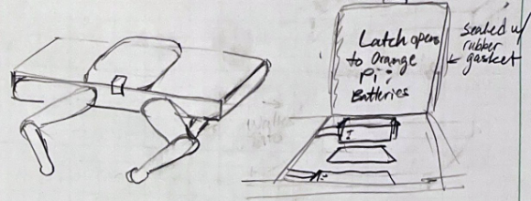

Figure 7. Complete roof covering plus latched cover to access Orange Pi and batteries on the robot. Electronics that do not need to be accessed often can be designed to be placed under the solid roof.

**Power System and Batteries**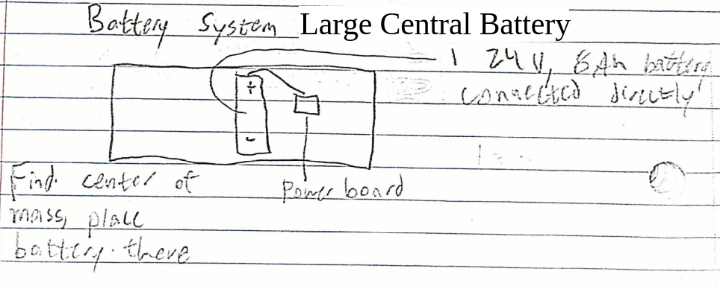Figure 8. A possible battery configuration involving one 24V battery placed at the center of the robot.

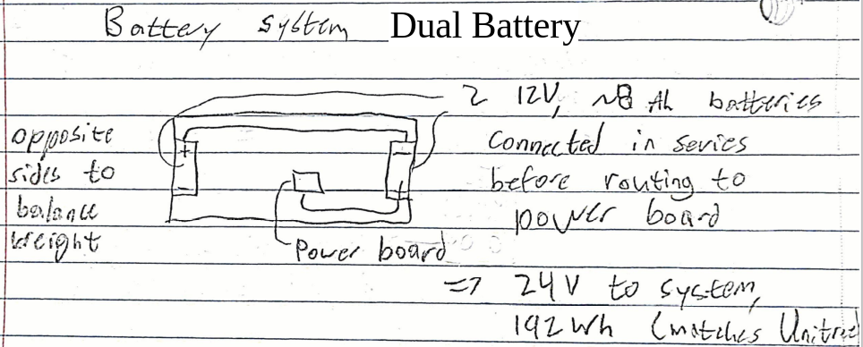

Figure 9a. A possible battery configuration involving 2 12V batteries on either edge of the robot.

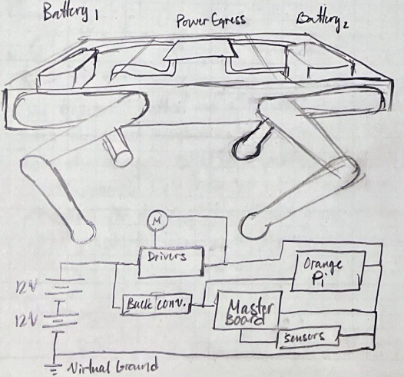

Figure 9b. Expansion on 12 V battery design

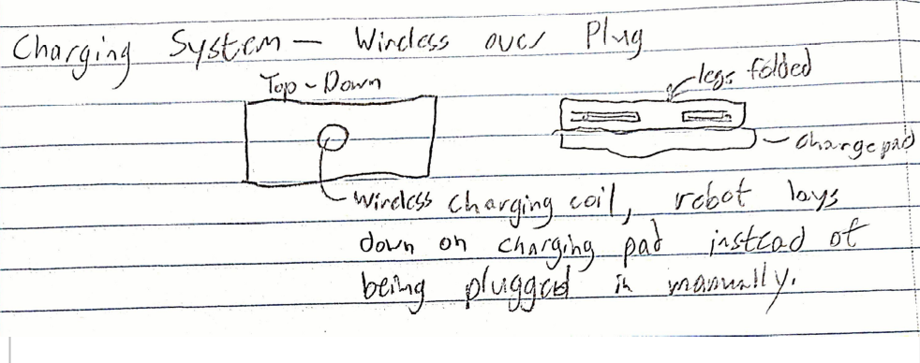

Figure 10. A possible alternative to the Open Dynamic Robot Initiative’s default configuration of a manually attached charging plug in the form of a wireless charger and charging pad.

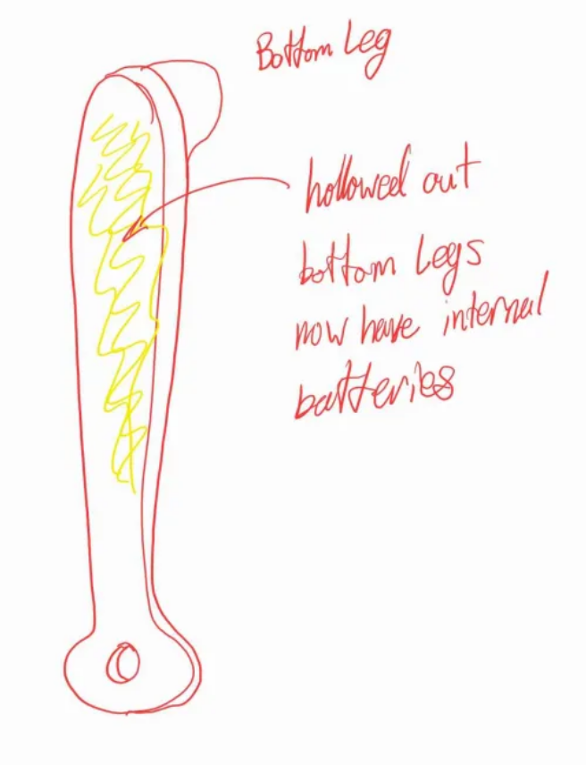

Figure 11. A potential battery arrangement for maximum stability by integrating batteries into the bottom of each leg, which is already hollowed out.

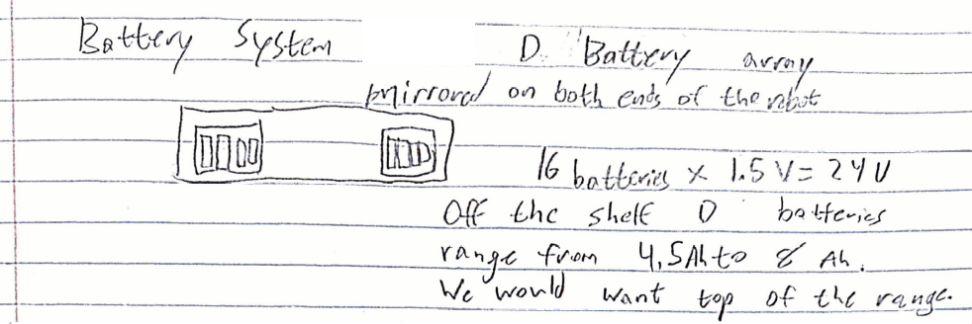

Figure 12. Another possible battery arrangement using either replaceable or rechargeable standard batteries in series.

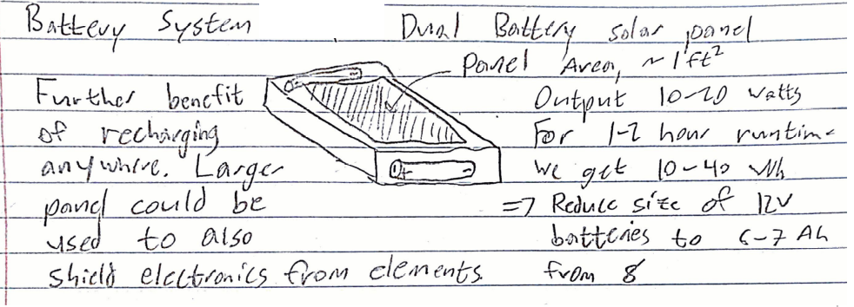

Figure 13. A possible addition to a previous battery system. The addition of a solar panel would allow for a reduced battery size while maintaining the same range, with the added benefit of not necessarily having to plug in to charge.

**Carrying Case**

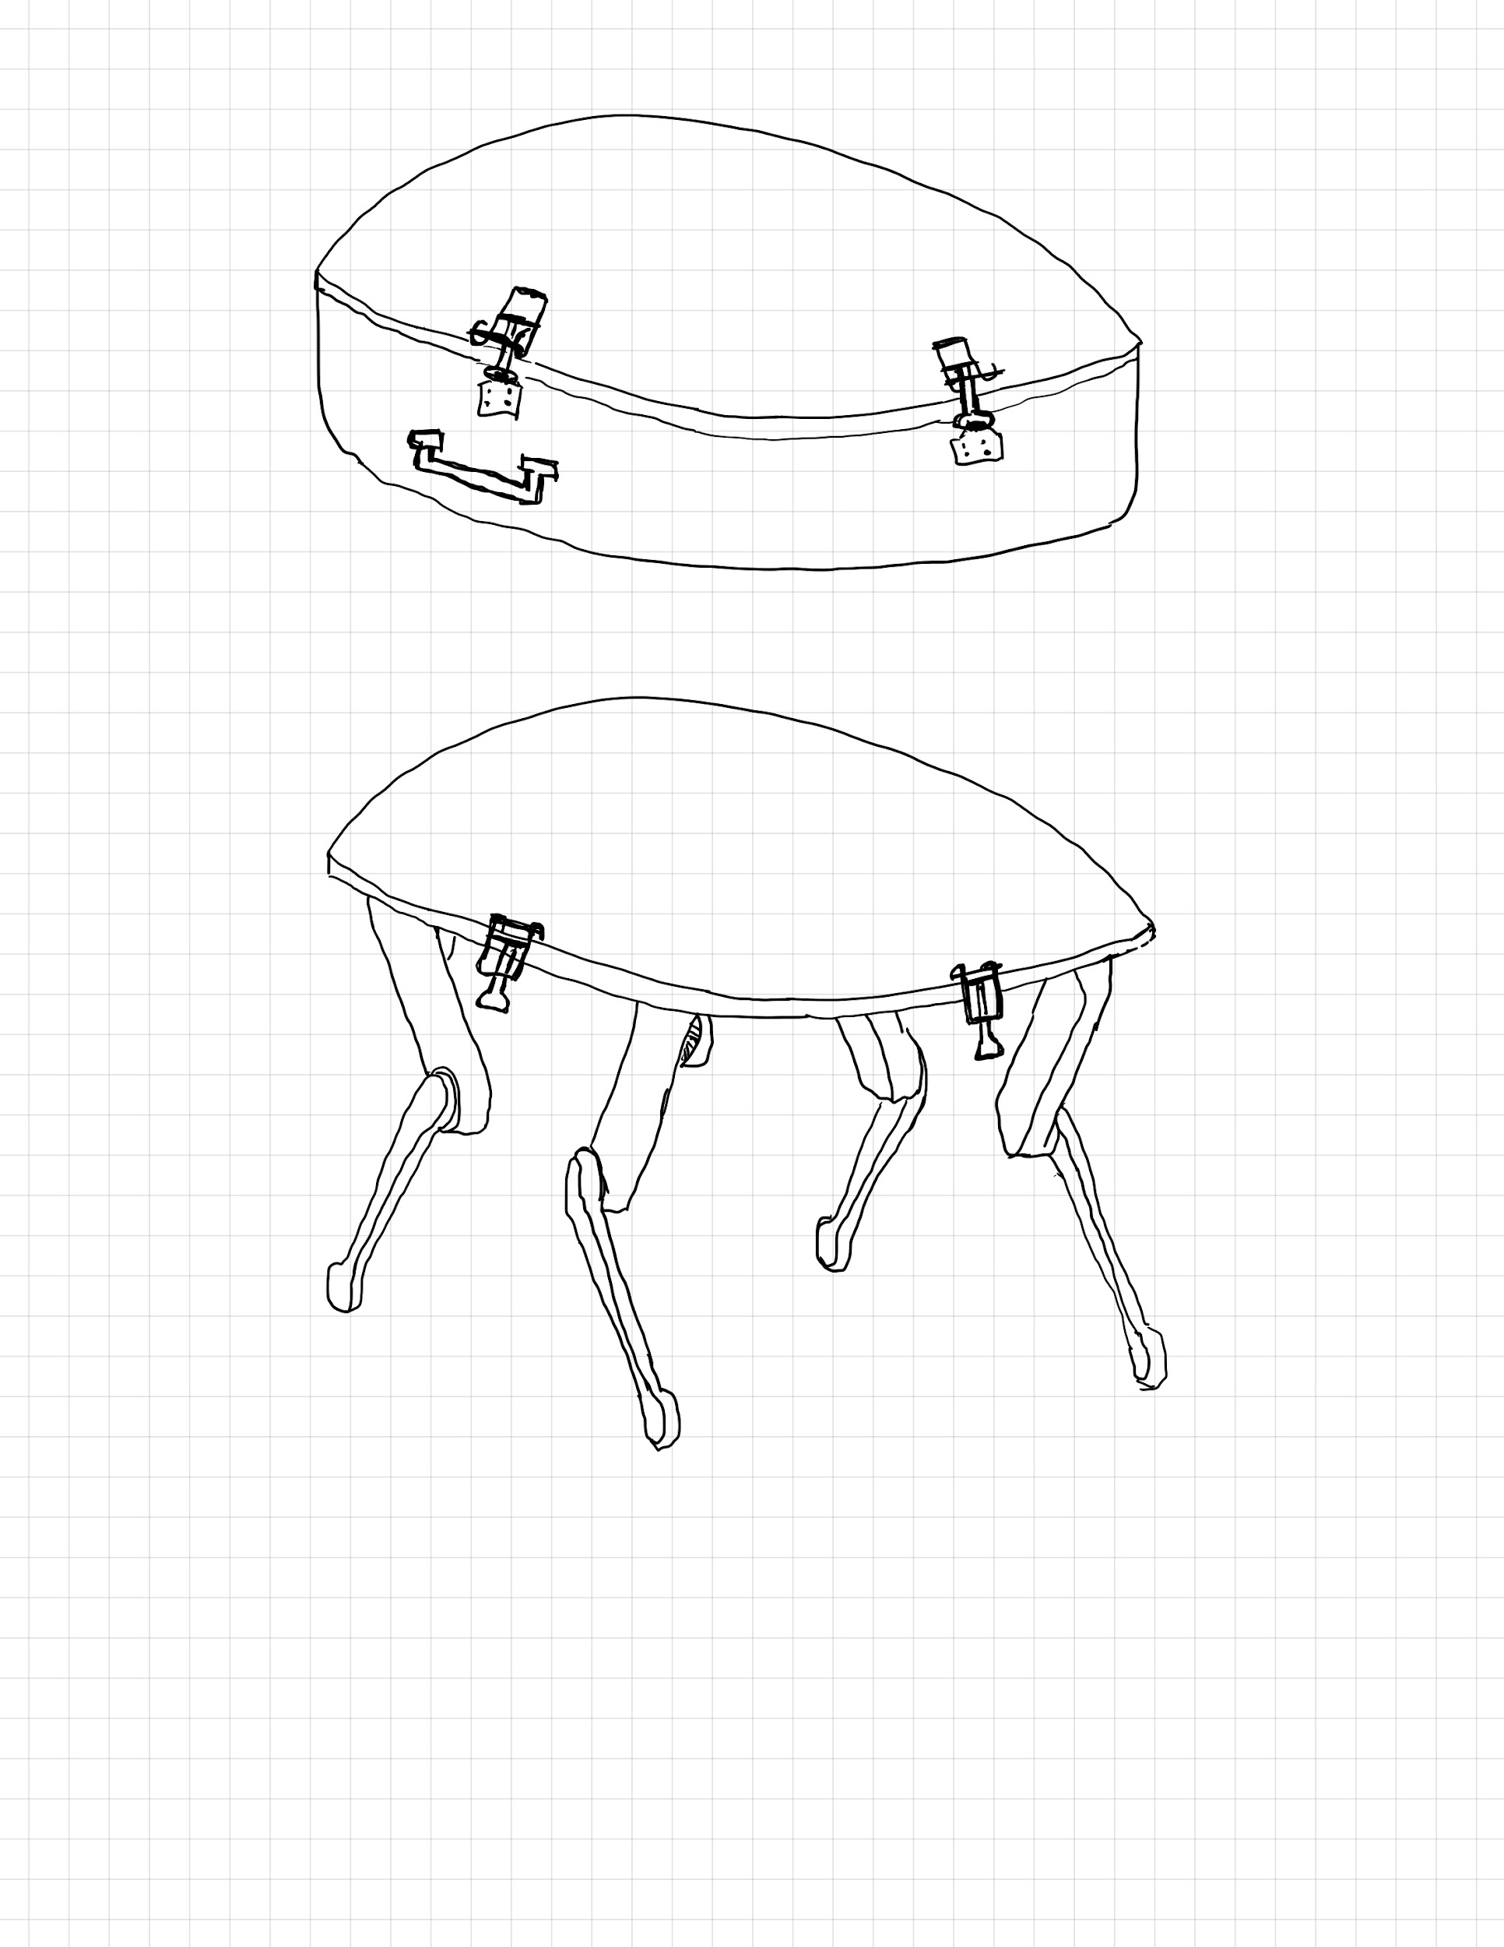

Figure 14. Weather cover for electronic parts doubles as lid with over center latches. It combines with a lower piece to make a briefcase style carrying case.

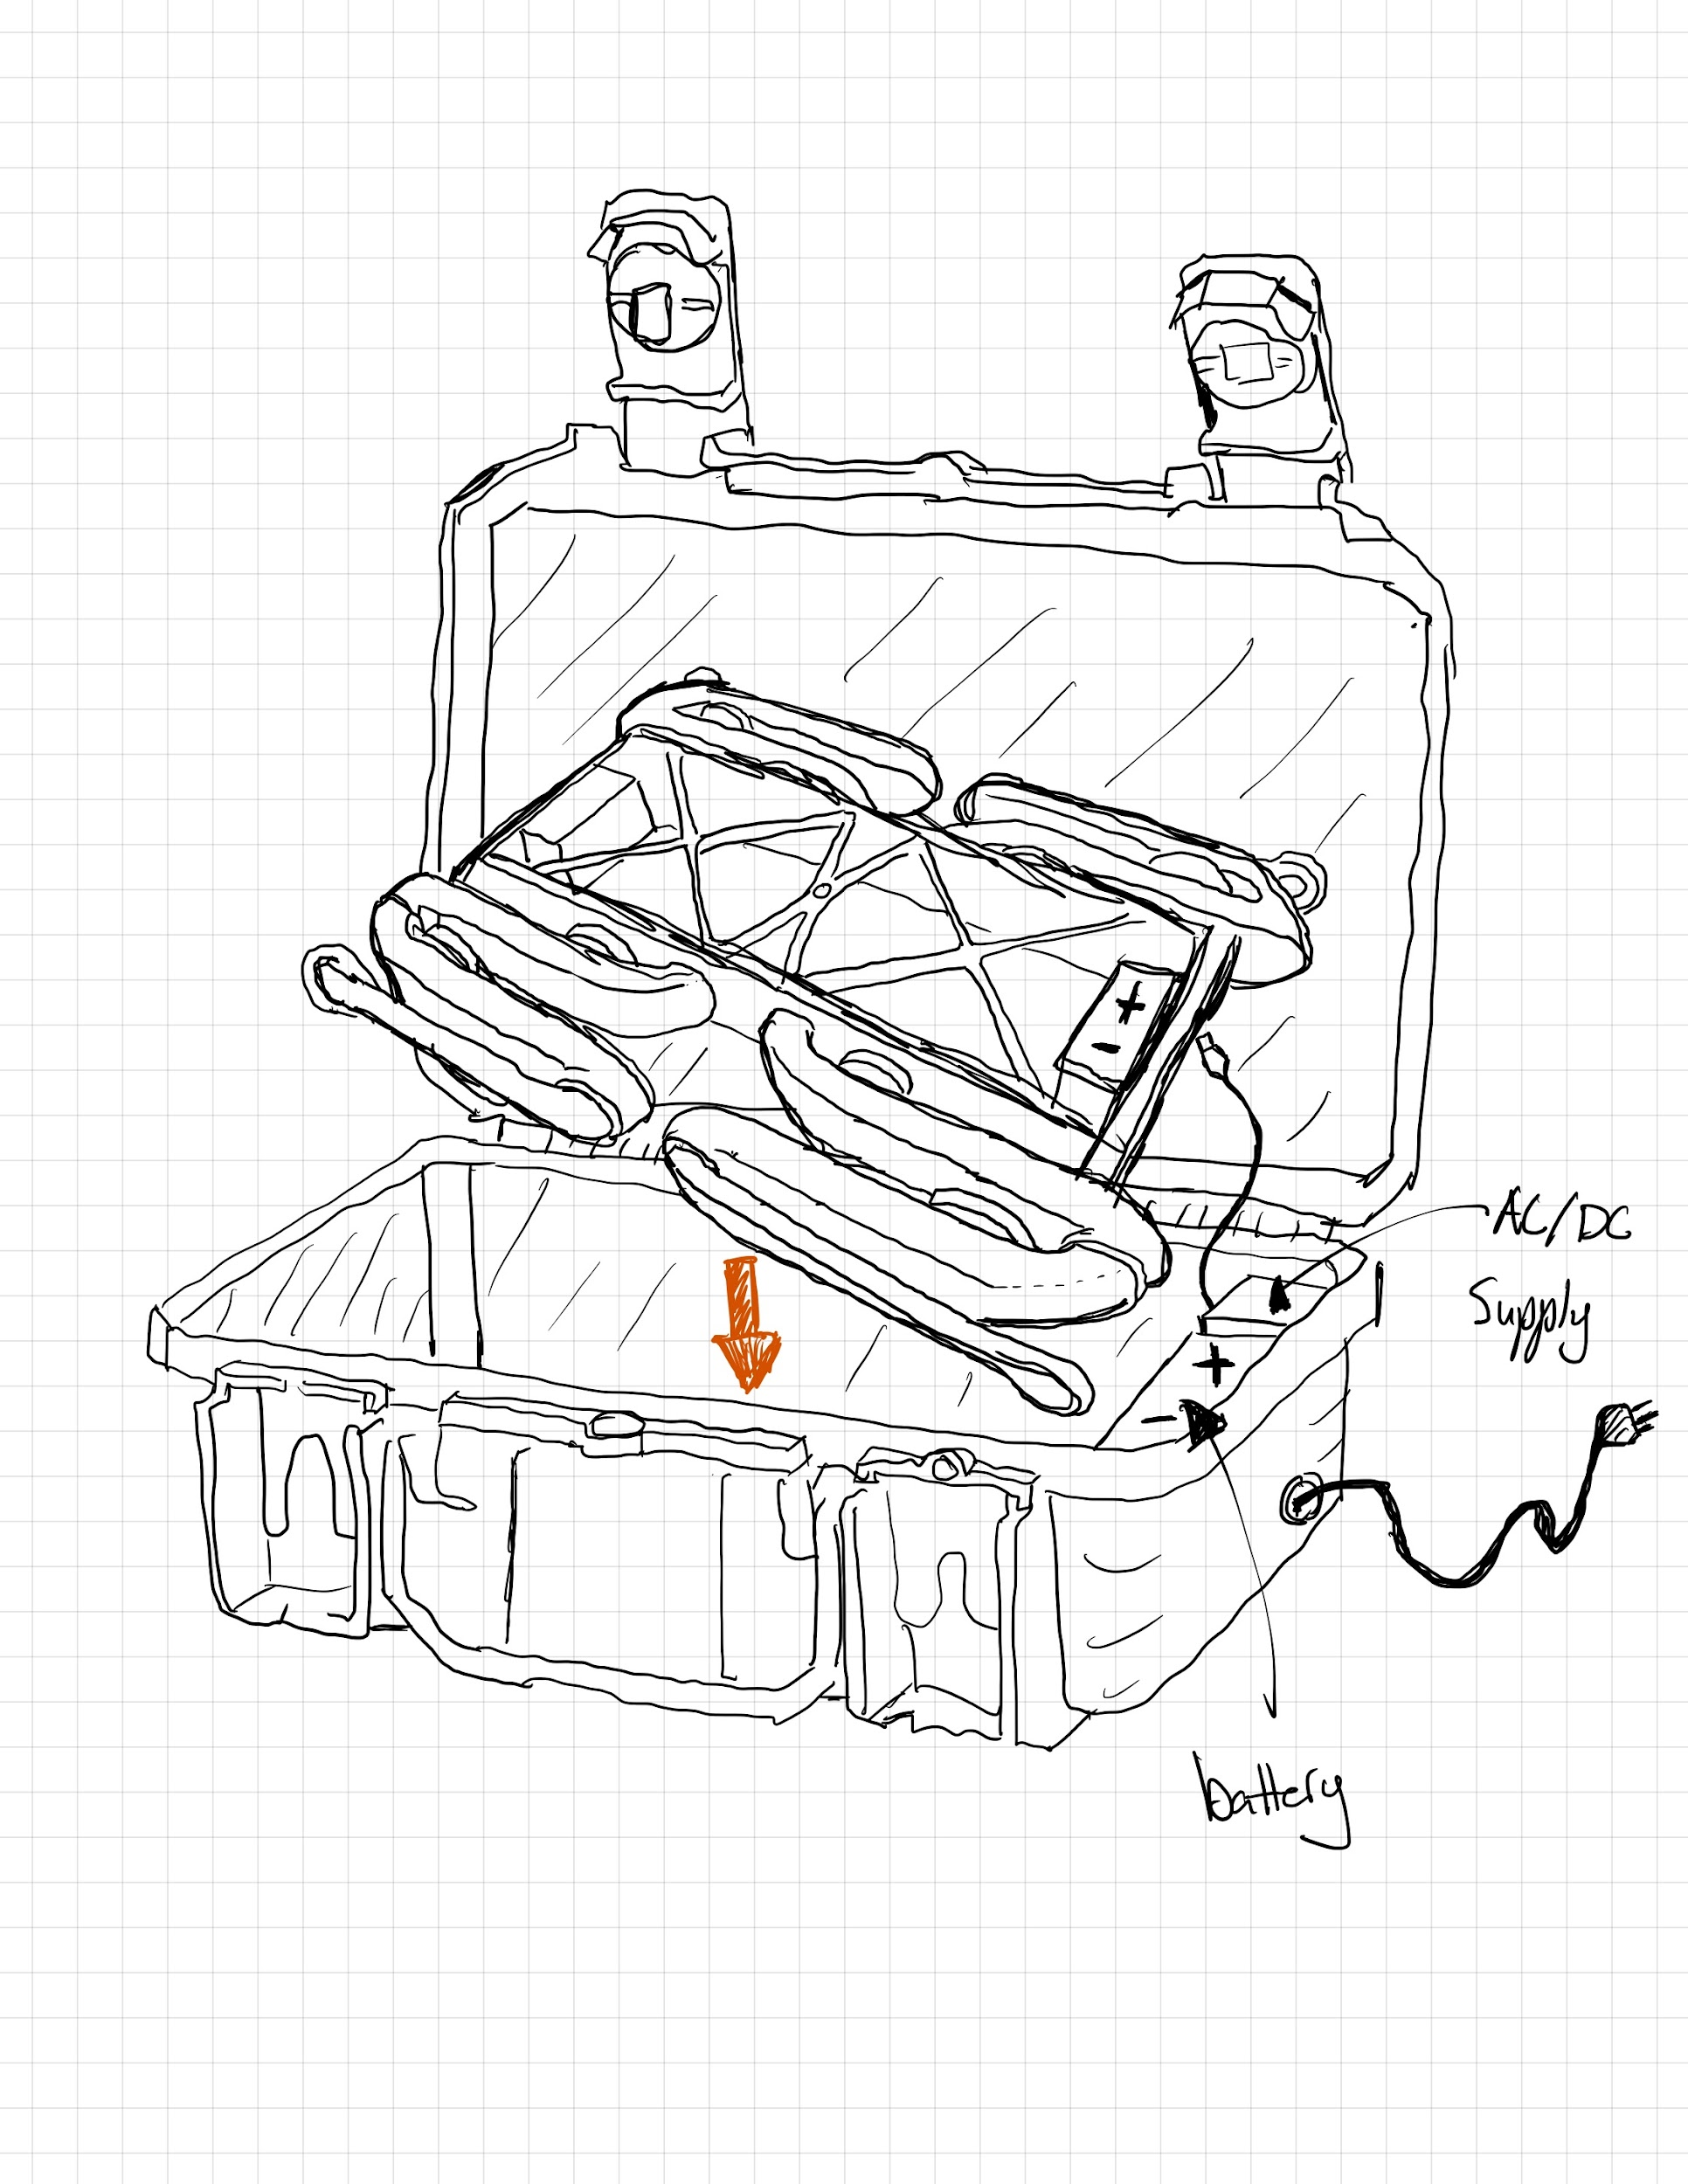

Figure 15. A case with AC/DC supply plus a battery. This case acts as an in-field backup battery as well as a “home base” charging station for the robot.

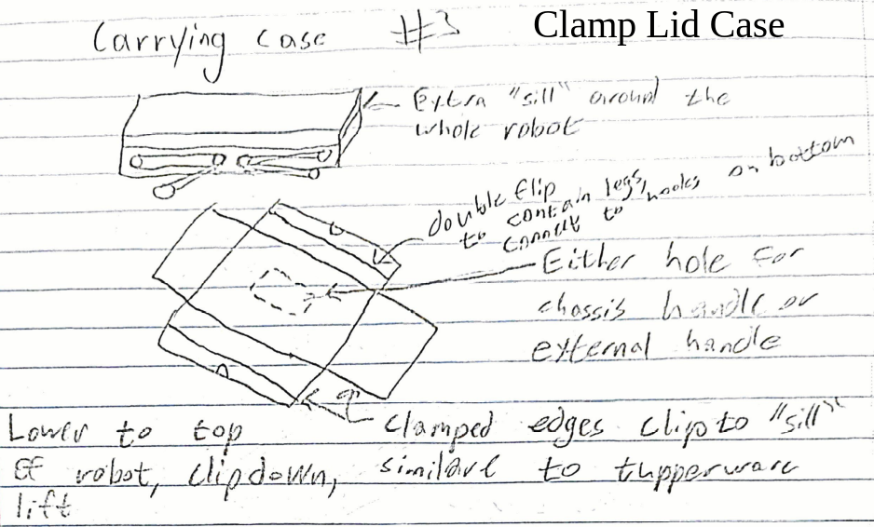

Figure 16. A case designed to be placed on top of the robot then clamped to the sides for easy transport.

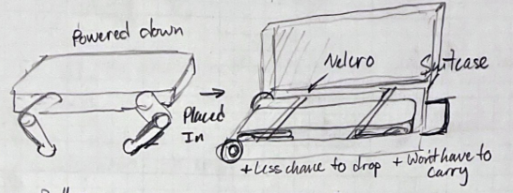

Figure 17. Robot suitcase carrying system, secured with velcro. Easier to carry, less worry about dropping, and can expand to hold more things in the top part of the suitcase.

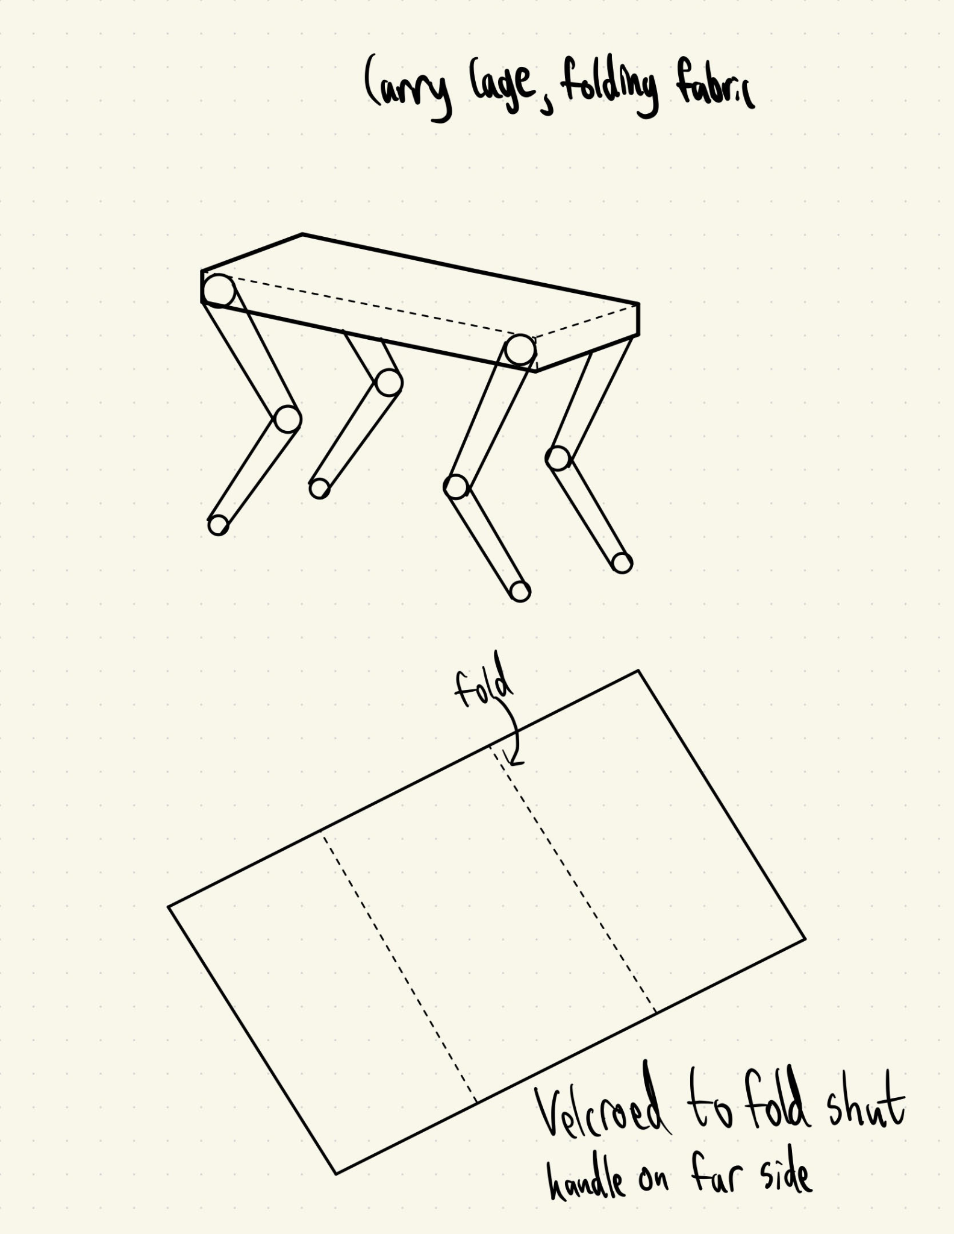

Figure 18. Folding Fabric Case, secured with velcro. Easier to carry, easy to put robots in, and can expand to hold more things in the top part of the suitcase. Very cheap and simple to make.

**Modular Connection System**

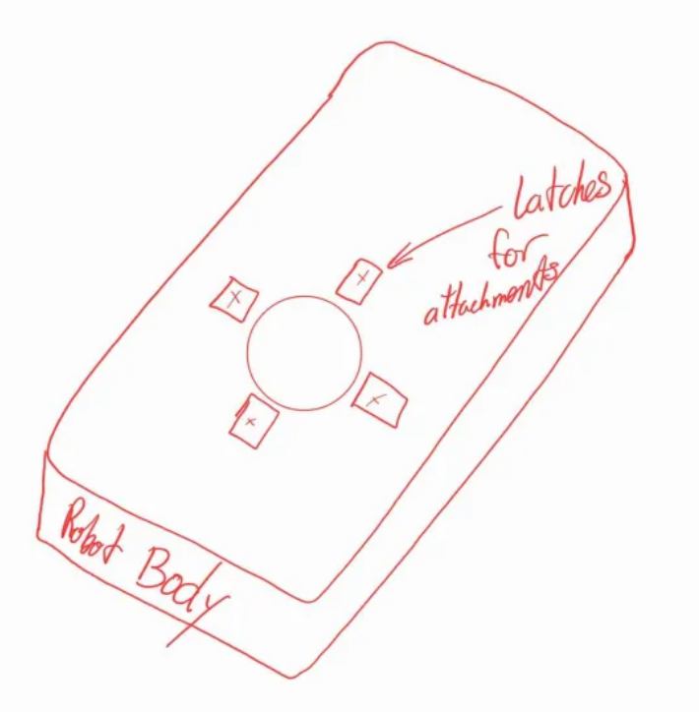

Figure 19. A possible physical connector for a module using clamps.

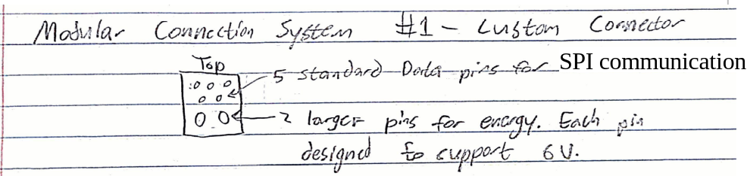

Figure 20. A possible electronic connection for a modular system using a set of pins wired to the SPI bus and a pair of pins for power. Each module would have only the connectors for the parts needed e.g. if it only needed 6V it would only have one power pin header.

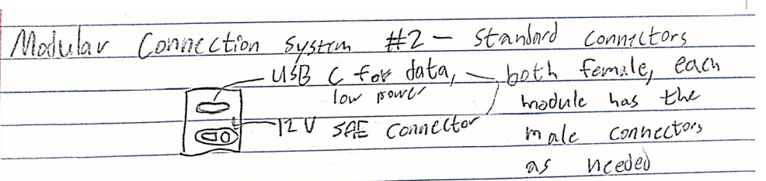

Figure 21. An alternate connection for a modular system. As in the previous, only the necessary connections would be used such as for a lower powered sensor that only needs USB power. This alternative would support more functionality and data transmission than the previous though it would be more expensive to implement.

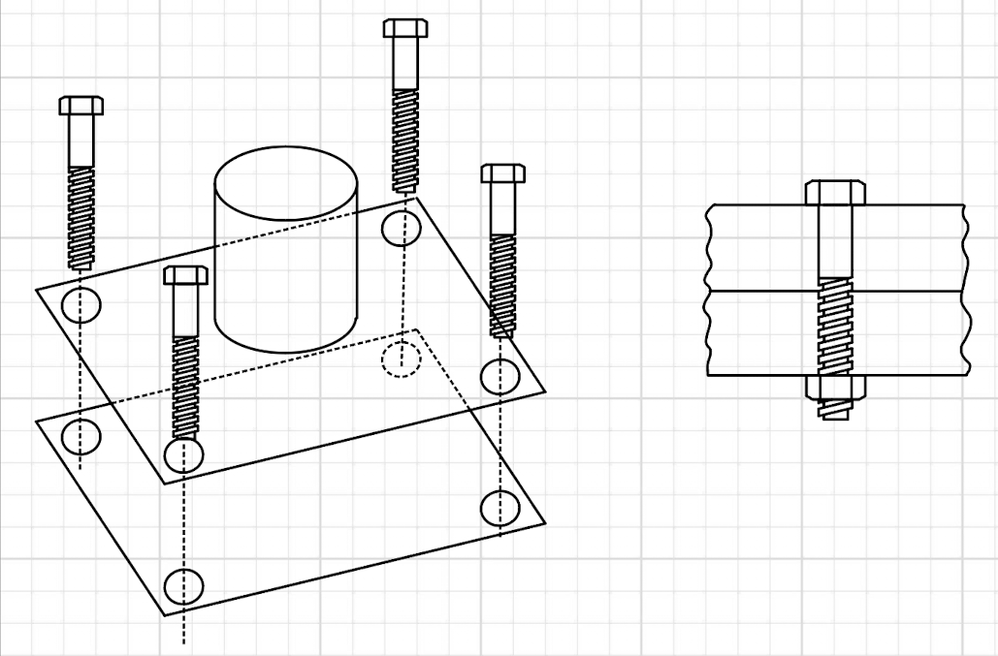

Figure 22. Bolted mounting system for modular nodes. This allows users to change out different sensors, robotic arms, or other devices.

**Part Printing Method**

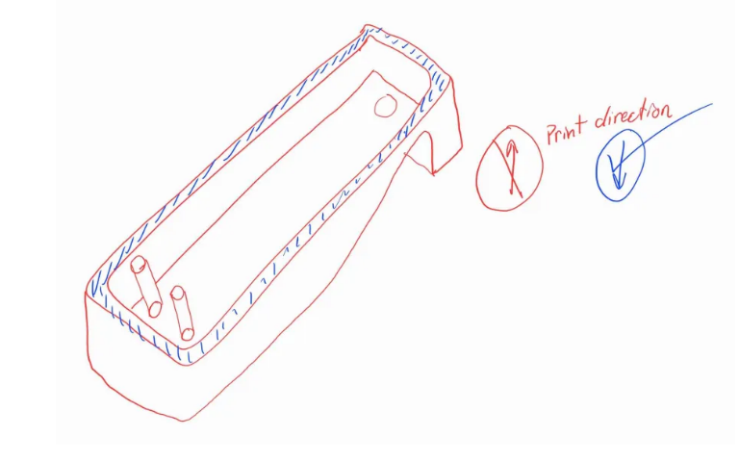

Figure 23. A quick sketch of the print changes made to improve surface finish.

**Handles**

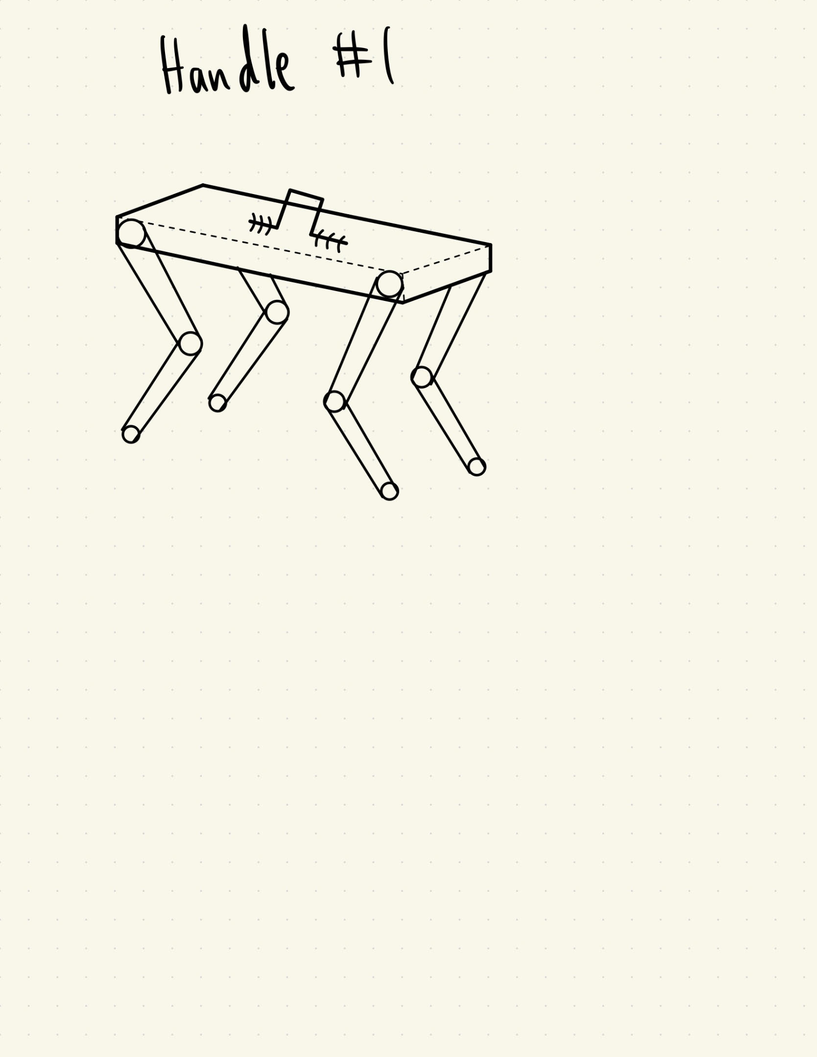

Figure 24. Single handle secured to the top and middle of the body of the robot. Easier to carry, very cheap and simple to make.

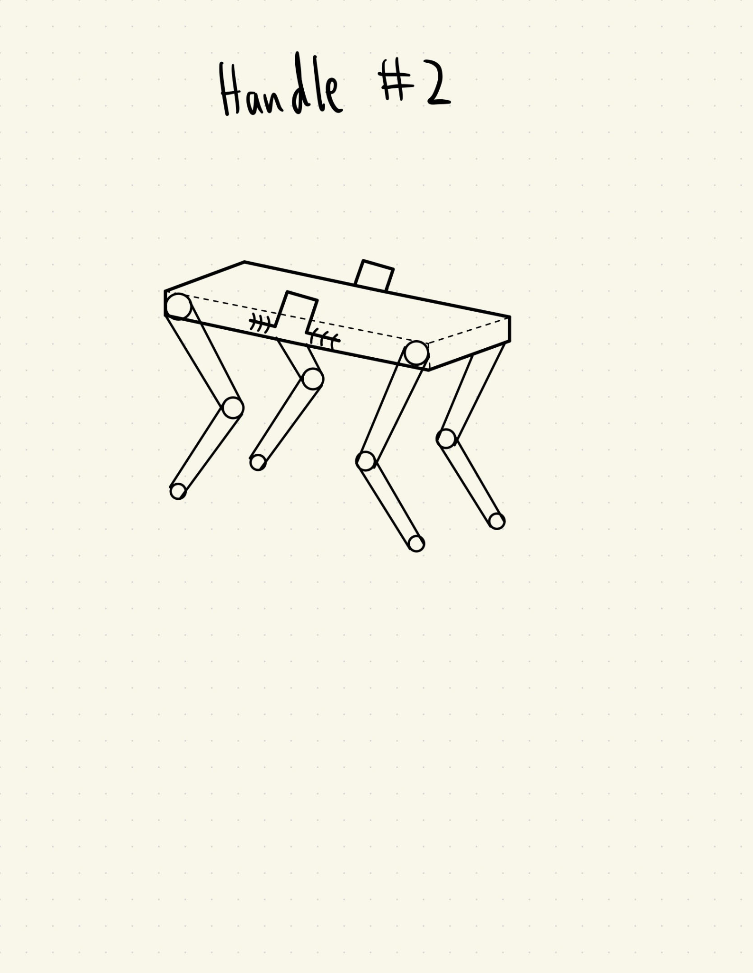

Figure 25. Two handles secured to the sides of the body of the robot. Easier to carry, very cheap and simple to make.

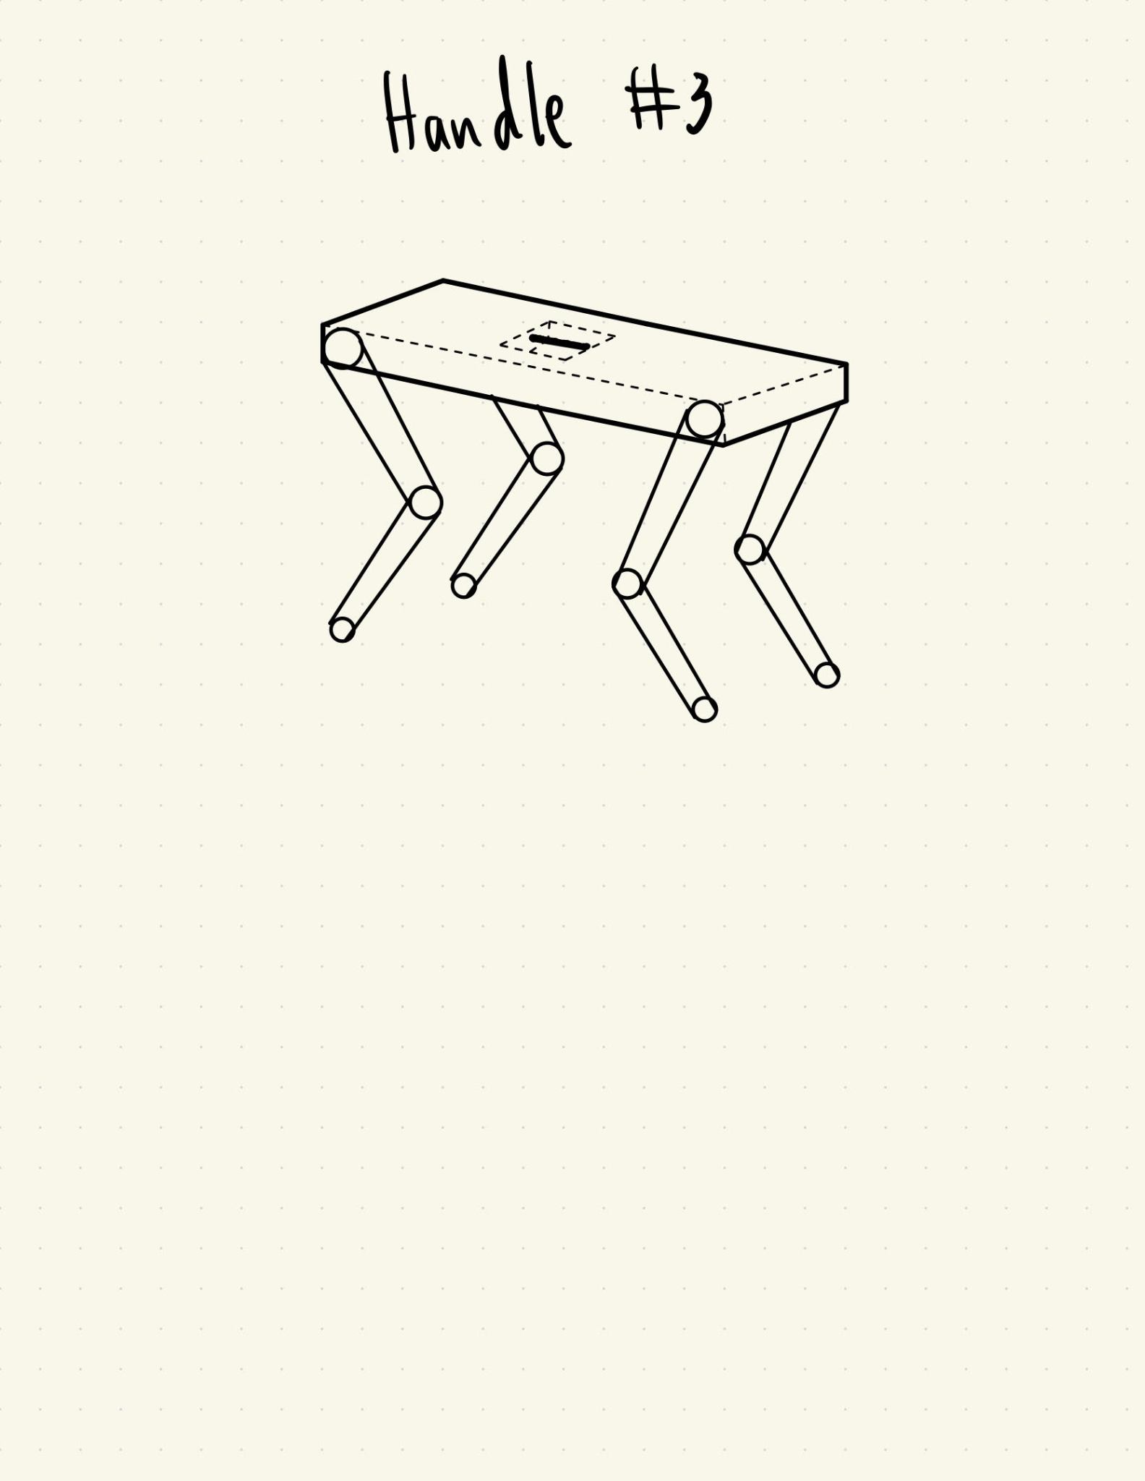

Figure 26. Single handle inlay into the top and middle of the body of the robot. Easier to carry, very cheap and simple to make. Nothing sticking out or protruding from the main body.



Figure 27. The rubber ring (in black) sits around a case that encloses the electronics. This helps waterproof the electronics from weather or sprinklers.

1. What brainstorming methods discussed in the course reader did you use in completing question 1? Were they effective? What worked well or did not work well? Provide documentation that shows your team using one or more methods (e.g. photo, annotations on concept sketches, etc.). (/3 points)

We used a morphological chart as can be seen on page 1. This method was effective for creating a more varied collection of ideas for improvements we could make to the Open Dynamic Robot Initiative 8 DoF robot design. Though we sometimes struggled to find further ideas for each “function,” simply focusing on one part of the robot and discussing it as a group led to breakthroughs we certainly would not have encountered on our own. The biggest issue we ran into with the morphological chart was how to divide up the functions–we started with too specific ideas that we could only really come up with one or two concepts for, then broadened the categories too much and started having overlap. After that, however, we were able to find a good balance.

1. Design Concepts (/50 points)
2. Pick the most promising concepts from your brainstorm and prepare 1 full page write-up for each concept. Concepts can be full device designs or subsystems. The number of full page concept write-ups must be at least the number of people on your team (e.g. six person team = six full page concept write-ups). For each full page write-up:
   1. Provide a detailed drawing of the concept (~ half to ¾ of a page). Drawings must be in the form of digital sketches (e.g. PPT sketch, CAD, tablet/stylus drawing, etc.) (/3 points).
   2. Label parts/features on the drawings (/3 points).
   3. Provide a 1 paragraph description of what the concept is, how it works, and expected pros/cons (/4 points).

Each full page concept drawing will be graded /10 points, as indicated above. Total points will then be scaled to a grade out of 50 to account for different sized teams (e.g. For a four person team, 36/40 = 45/50).

**Dual Purpose Lid with Case (Full Concept 1)**

| Figure 28. Robot in walking mode | Figure 29. Robot folds into cover/lid |
| --- | --- |
| Fig 30. Robot top case piece, with mounts | Fig. 31 Robot inside a briefcase, latches engaged |

Pros: The weather cover covers not only the electronics in the chassis but the motors as well. The design accomplishes two of the goals in the morph chart.

Cons: The cover is not easily removable. The rigid full coverage design will be extra heavy.

This concept attempts to combine both the need for a carrying case as well as weather protection. The lid of the case acts as a cover for the electronics, battery pack, and extends to shield the motors as well (see Fig 1). The lid/cover includes four hooks. The lid is mounted to the chassis of the robot at four mounting points with bolt holes. When the legs are folded in, it can be lowered into the bottom half of the case. The bottom piece of the case includes a handle for easy carrying, briefcase style (see Fig 4.). The bottom piece of the case also has four latches which interface with the hooks on the cover/lid of the case.

**Untethered Power System:**

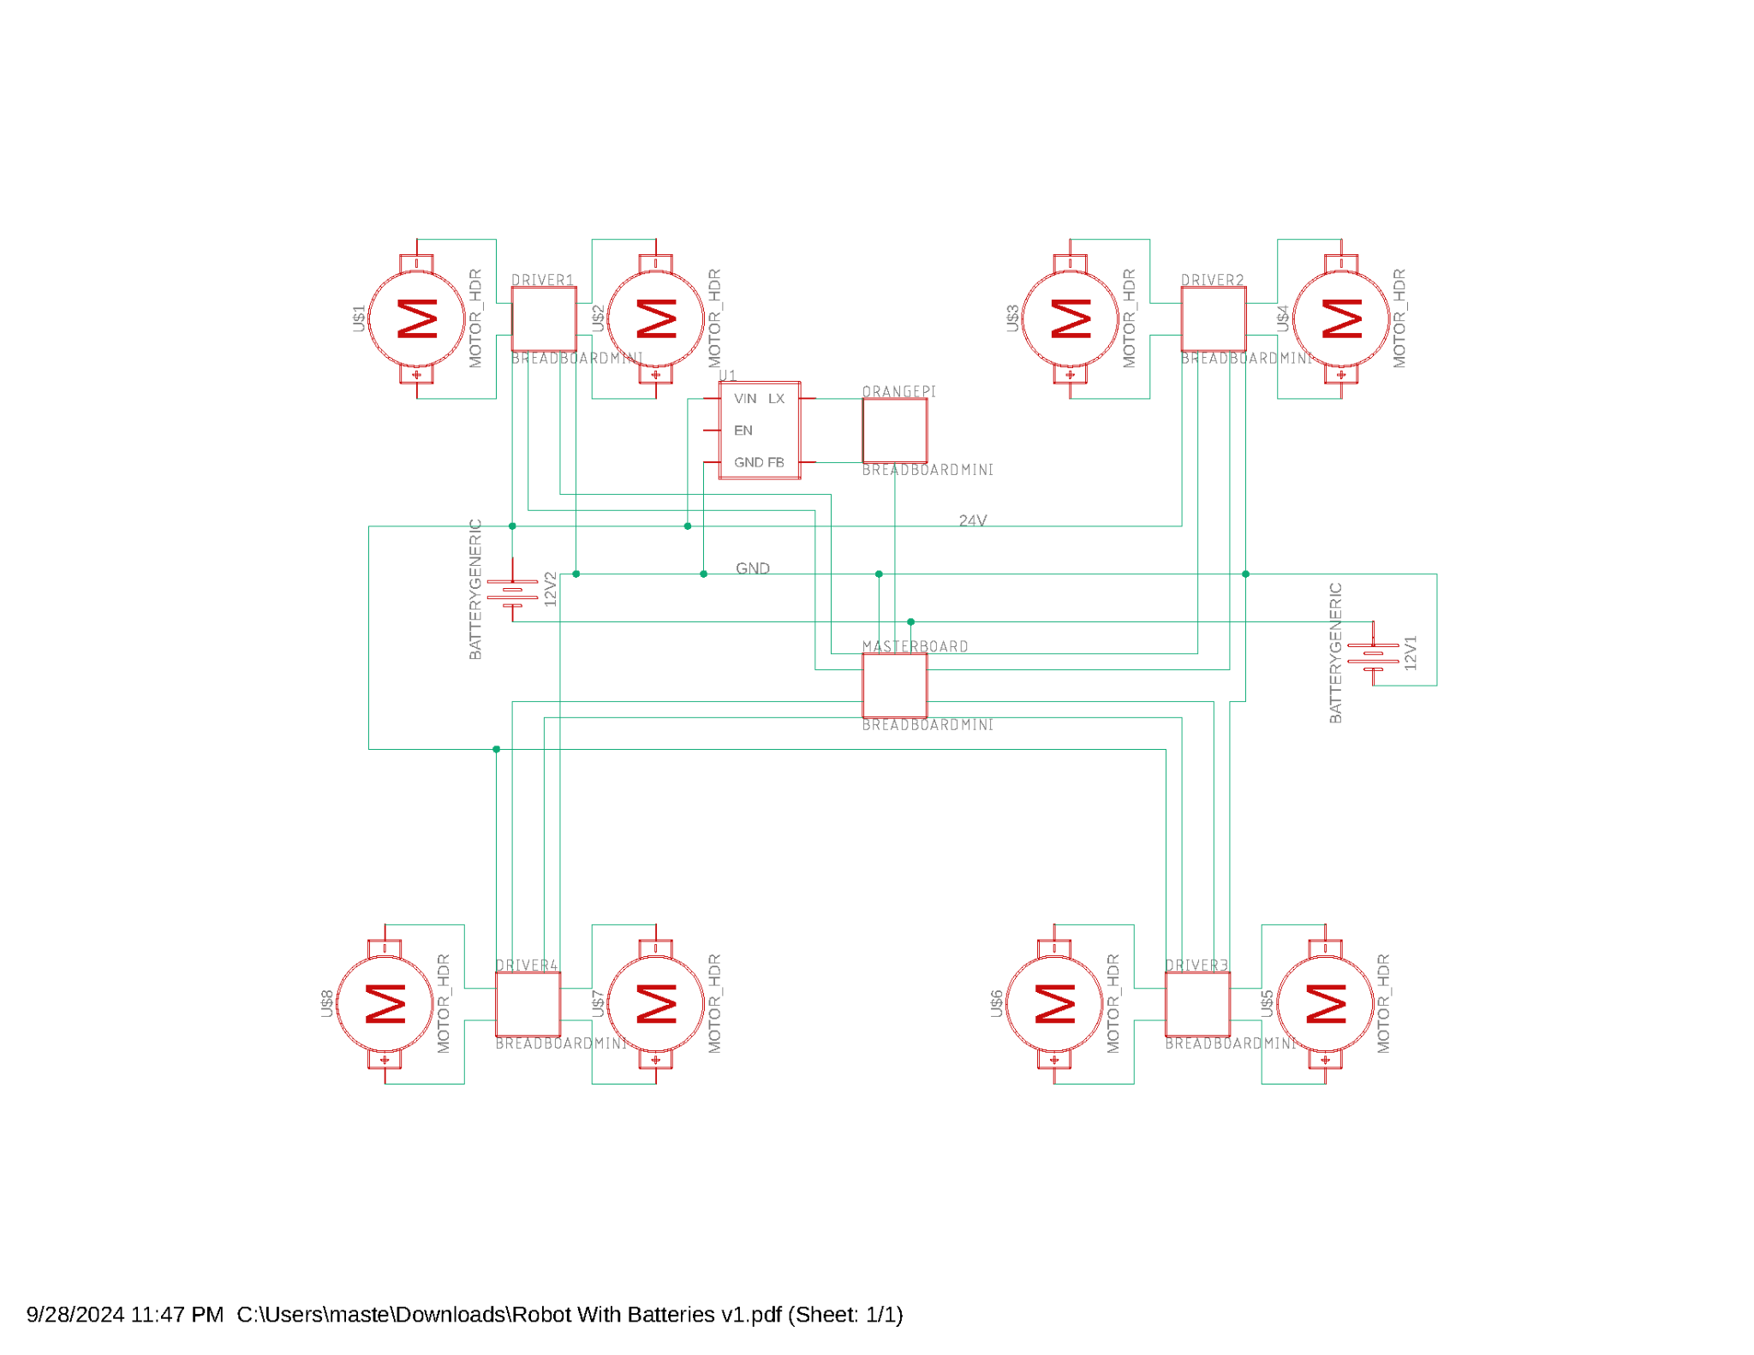

Figure 32.Electrical overview of the quadruped robot with the integrated computer and two 12V batteries

This concept is based off the “untethered” constraint of our robot. Two batteries on each side of the robot (to preserve center of mass) power the robot and connected to four motor drivers and the master board. The motor driver boards supply to the power to the motors and is the biggest spender of power. Over the one battery design, the two battery design has better weight balance. Conversely, 12V and 24V rechargable batteries cost similar amounts, so this design costs more. Further, it also requires a more complicated power board to apply the batteries as one 24V output.

**Table 1.**  Robot power system needs estimate

| **Name** | **Power Use** | **Quantity** | **Current** | **Voltage** | **Combined Power** | **Notes** |
| --- | --- | --- | --- | --- | --- | --- |
| MN4004 Brushless Motor kV300 | 90W | 8 | 3.8A | 24V | 720W | ~25% power |
| ORI Custom Driver Board | low | 1 |  | 24V |  |  |
| ORI Master Board | low | 1 |  | 4-60V |  |  |
| Orange Pi 5 | 20W | 1 | 4A | 5V | 20W |  |
| MicroStrain IMU | 0.5W | 1 | 0.1A | 5V | 0.5W |  |
|  |  |  | **Total Power** | | 740.5W |  |
|  |  |  | **Predicted Energy** | | 1.481 kWh |  |
|  |  |  | **Energy @ Max** | | 3.496 kWh |  |

**Redesigned Legs for Better 3D Printing**

| Bottom Leg | | Main Leg (Design) | |
| --- | --- | --- | --- |
| Old | New | Old | New |
|  |  |  |  |

| Main Leg (Printing Orientation, Red is the printing bed) | |
| --- | --- |
| Old | New |
|  |  |

This design change was made because of the complex shapes and odd printing orientation in the original model. The new design aims to remove the extreme slopes that are near the joints and surface where the shell and cover connect for easier printing. The original design's extreme slopes would result in random blobs of PLA forming, this would require sanding to get rid of these imperfections. The sanding would then have a gap between the cover and the shell. The new design completely gets rid of this issue. The print orientation changes where the supports are needed for the leg while it is printing (making the outside of the leg smoother).

| Pros | | Cons | |
| --- | --- | --- | --- |
| No sanding needed  Doesn’t change anything internally | Flat surfaces between shell and cover  Easier/faster construction | Takes slightly longer to print | Slight increase in weight |

**Data and Power Connection for Robot Modules**

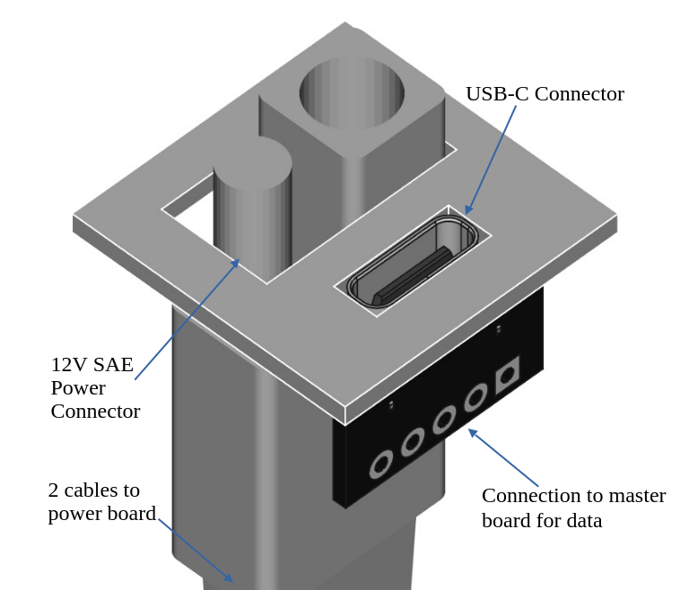

Figure 33. A theoretical data and power connection for robot modules. The panel containing the ports would be part of the robot’s back panel.

This modular system is designed using off the shelf connectors to make it easy to source connectors for the modules themselves–each plug was available on Amazon for ~$8. Though affordable, this is more expensive than a custom exposed pin type solution. The USB board would be wired to the master board, including a 3.3V power wire. Consequently, for low power sensor modules no SAE connector would be necessary and the module could be run off the USB port exclusively. The SAE connector would be attached to the power board, taking 12V off of it to run higher power systems. Some limitations of this system include being limited to the USB standard of information transmission, needing higher quality and more expensive USB connectors for sensors with high data throughput, and the mechanical connection system would need to be very precise to ensure the electrical connectors align perfectly.

**Large Feet for Muddy Conditions**

| Figure 34. Single lower leg. | Figure 35. Quadruped robot with four larger feet for muddy conditions. |
| --- | --- |

There are a lot of environmental factors in agricultural fields that can cause issues when using a quadruped robot like this. One major problem that it might face is muddy conditions. This foot design concept is much larger than the previous version to increase its surface area, almost like a snowshoe. The cylindrical aspect would not only allow the legs to rotate with the same foot shape, but it would decrease any suction cup effect a flat foot would create with the mud. The hole in the center significantly reduces the weight the motors have to lift, however, they are still much heavier than the original, smaller design. This is the biggest problem when making a larger foot like this. Not only would it affect the power required from the motors, but there might be some undesirable effects on the control algorithm and decreased response times.

**Two handles for easy carrying**

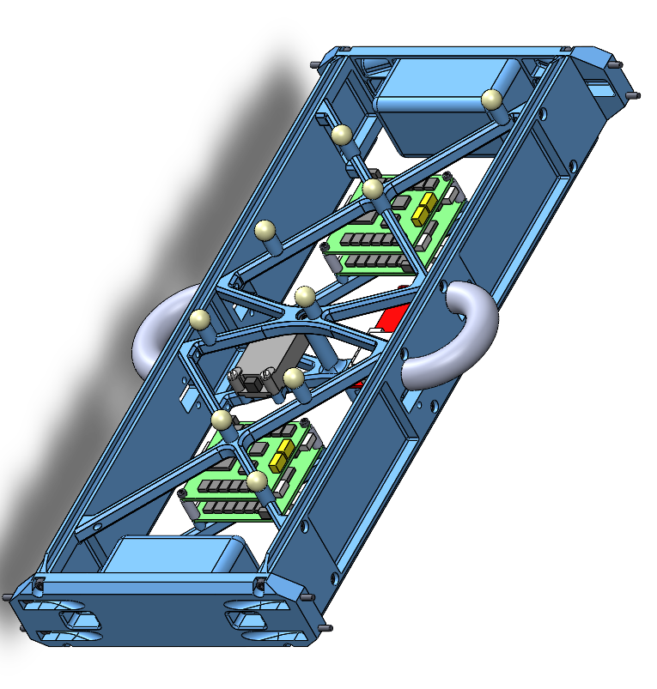

Figure 36. Robot body with two handles for easy carrying.

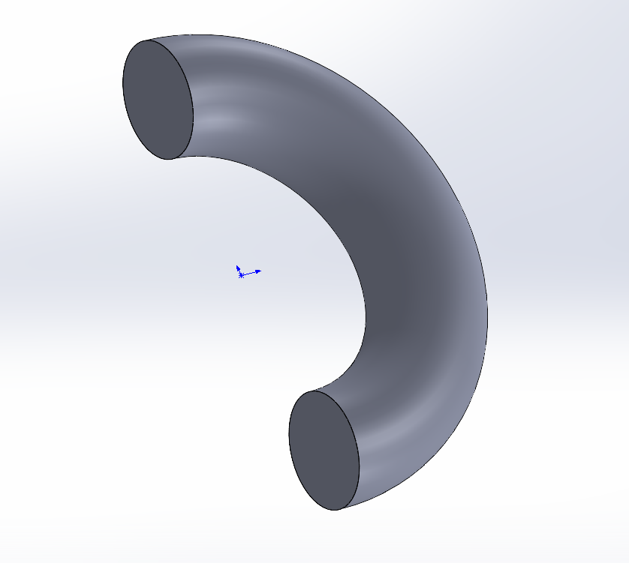

Figure 37. Close up of the handle.

This would be an easy add-on and printed into the body of the robot. The handles were designed to be large enough to fit more than 2 fingers (35mm across), while not being too big to cover a large portion of the robot. An added benefit is that if the robot were to tip over on its side, the handles would help brace the fall and take part of the impact. Also, it is hard for the robot to get back up if it fell a whole 90 degrees onto its side. With the handles it allows for the robot’s side to be off the ground a little bit and to help it get a leg under it to stand up easier. This addition will aid in the convenience and ergonomics of the quadruped robot. Cons of this design are that it increases the weight and may influence the gait. Further, they require the body of the robot to be reworked to ensure the handles can bear the full weight of the robot.